

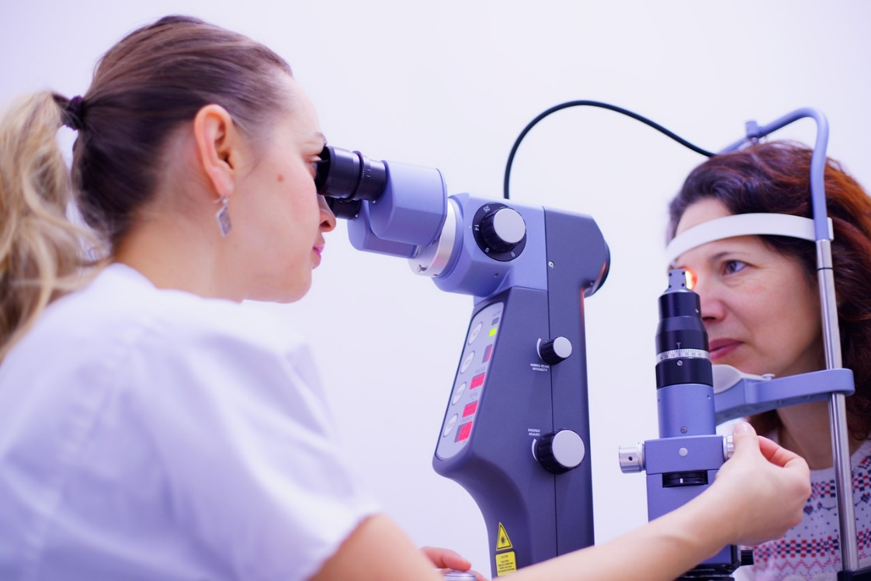

CUES (Community Urgent Eyecare Service) online survey responses

Engagement Report
Engagement dates: 4 November 2024 – 5 January 2025
The Leeds office of the NHS West Yorkshire Integrated Care Board (The ICB in Leeds)
Date of publication: February 2025

Executive summary
This engagement activity was planned to capture feedback from staff and patients of the Community Urgent Eye Service (CUES) in Leeds, as a change to how people access the service was trialled from 1 November 2024.
The online survey was available to staff and to people using the service. Twenty-seven people responded altogether, evenly split between staff and patients. Although the number of people responding to the survey was low, the existing provider (Primary Eyecare Services Ltd or PES) continued to collect patient satisfaction feedback before and after the change, which showed that satisfaction rates remained relatively consistent before and after.
Responding to the survey, patients reported a mixture of positive and not so positive experiences. Staff within the services also reported some frustrations with the change to the service. However, some respondents were positive, and many also provided detailed responses which were useful for understanding and addressing some of the teething problems with the change.
Feedback from the survey will build on a recent service review, and contribute to wider plans for service development which aim to develop and improve the care people with urgent eyecare issues in Leeds receive.

Contents Page

Background 3
Who responded to the survey? 4
What did people tell us? 5
Feedback from people who had used the service 5
Feedback from members of staff 11
Equality monitoring data 15
Next steps 16
Appendix 17

Background

Changes to the Community Urgent Eyecare Service (CUES)
The Community Urgent Eyecare Service (CUES) in Leeds has provided fast access to eye problem assessments since August 2020. First designed to treat urgent symptoms only, over time, many people with non-urgent symptoms have started using the service. It is commissioned by the Leeds office of the NHS West Yorkshire Integrated Care Board (ICB in Leeds) which plans and pays for health and care services.
A review of the service was carried out following a recent (February 2024) upgrade to the national standard clinical specification for Community Minor and Urgent Eye Care Services and in relation to wider pressures affecting the NHS, with the ICB in Leeds facing considerable financial challenges.
The service review highlighted the opportunity to be clear about what eye problems the service can help with, and when it needs to signpost people to more appropriate support, such as local pharmacies.
It was also an opportunity to look at how people access the CUES service. From 1 November 2024, everyone seeking help will do so in the same way; by contacting the service on one phone number - 0300 303 4922. Before this, some people rang the phone number while others spoke to staff face-to-face in optical services.
The current contract for the CUES service in Leeds ends on 31 March 2025 and a new contract will begin from 1 April 2025.
This survey aimed to collect feedback on how people accessed the CUES service, and their experience of using the service, and also how staff in services found the transition to the single point of contact phone number. Feedback from the survey will help inform the new contract, with the main aim being to develop and improve the care people with urgent eyecare issues in Leeds receive.
The survey opened on 1 November 2024, and closed on 5 January 2025. Primary Eyecare Services (PES) which provides CUES in Leeds, provided details about the survey to the local optical services delivering the service. The ICB in Leeds produced and delivered information materials to the services, explaining the change and encouraging staff and service users to complete the online survey to provide feedback.

Who responded to the survey?

26 people responded to the survey:
- 11 people had used, or were using, CUES in Leeds.
- One person was a carer, friend, or family member of someone who had used, or was using, CUES in Leeds.
- 11 people were members of staff, working as part of CUES in Leeds.
- Three people were members of staff, working in another service (including third sector services).
Responses were fairly evenly split between people who have used the service, and staff.
The number of responses to the survey overall was disappointing. However, throughout the change process, PES continued to collect feedback from people using the service through Patient Reported Outcome Measures (PROMs).
The report for November and December 2024 shows that 222 people provided feedback about their experiences of using the service, with 12 (5%) saying that they would not recommend the service, and 210 (95%) saying that they would.

Feedback from people who had used the service (including one response from a carer, friend or family member) – 12 respondents.

People who had used the service provided the first part of their postcodes. The map below shows the location of the postcodes provided:

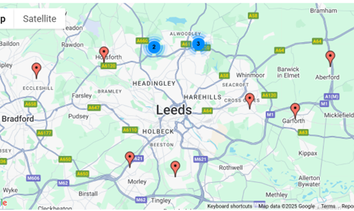

What did people tell us?

1) We asked people how long ago they had used the service:
- Three people said it was before 1 November 2024
- Nine people said it was on or after 1 November 2024

2) We asked people if they got the help that was needed for their eye problem as a result of using CUES:
- Nine people said yes, they had.
- Two people said no, they had not.
- One person said they had, to some extent.

3) We asked people to say how satisfied they were with their experience of CUES:
- Four people said they were very unsatisfied
- Four people said they were somewhat satisfied
- Three people said they were satisfied
- One person said they were very satisfied

4) People were asked if they would like to give more detail about their answers:
Ten people provided a response to this question. Their responses have been summarised using ChatGPT. A full transcript of their responses is included in Appendix 1.
The summary outlines multiple individuals' experiences with CUES, highlighting a mix of frustrations and positive aspects:
Frustration with Wait Times and Inefficiency:
Several people reported long wait times on the phone, being disconnected, and not receiving promised call-backs. Some also expressed frustration with the convoluted process of referrals, which involved unnecessary delays and multiple steps (e.g., being referred to CUES only to return to their optician).
Challenges in Accessing Timely Treatment:
Many felt the system delayed timely care, requiring them to wait too long for appointments or prescriptions. One person mentioned needing antibiotics but couldn’t get them due to logistical issues over the weekend.
Mixed Service Quality:
While some praised the professionalism and empathy of the staff, particularly in terms of diagnosis and advice, others felt the service was ineffective and time-consuming. A few suggested allowing patients to directly access their local optician for immediate care, rather than going through a lengthy referral process.

Positive Aspects:
Some individuals appreciated the access to assessment and diagnosis, with one praising the clear explanation of next steps. A few mentioned that they were satisfied with the care they received, though some expressed dissatisfaction with the treatment process or lack of prescriptions.
In summary, while the service provides helpful assessments, it is hindered by long wait times, logistical issues, and a complex referral process that many feel could be streamlined.

5) People were asked how they had found out about CUES:
- Eight people said they had found out about it from a health professional.
- One person said they had used the service before.
- Three people said ‘other’, including one from Specsavers and one from NHS111.
Some respondents provided some additional information:
- Specsavers - she gave me a card
- Local optician
- GP referred me; unfortunately, the GP thought I needed to go to an optician. I don't think he knew the service had changed in Nov and so set poor expectations / advising wrong. All sorted out quickly so not an issue at all in the end.
- My optician
- Redirected by 111
- I called my regular optician, and they said I had to use CUES
- I had a problem & contacted the Dr. They told me I needed CUES and gave me the number.
- GP gave the info via patches.

6) People were asked how long it took to get through on the service number to speak to someone:
- Five people said ‘Under 10 minutes’
- Two people said ‘Between 10-20 minutes’
- Five people said ‘Over 20 minutes’

7) People were asked how helpful they found the telephone assessment:
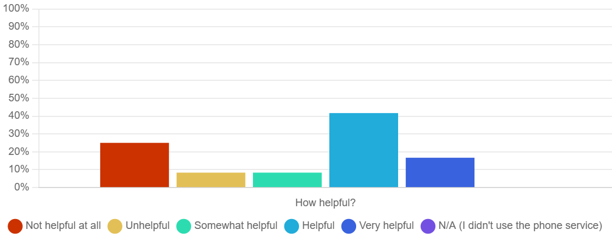

Three people said ‘Not helpful at all’
One person said ‘Unhelpful’
One person said ‘Somewhat helpful’
Five people said ‘Helpful’
Two people said ‘Very helpful’

8) People were asked if there was anything else they would like to tell us about the telephone assessment:
- I didn't manage to get through to anyone and they put the phone down on me twice.

- On hold for a total of 75 mins over 2 calls, so no telephone assessment done.

- The lady I spoke to was knowledgeable, friendly and empathetic, and made what felt like a reasonable diagnosis, recommending over the counter treatment, and emphasising when I should call back if I still had pain.
The limitation was that the pharmacy didn't understand the recommended treatment, so this element of the process was not great.
- Can’t diagnose an eye issue over the phone.

- Person taking the call was polite.

- Initially the triage call said I didn't need to be seen, I explained I had previously had scleritis and she agreed to give me an appointment at LTHT. I did have scleritis again!

- The first time I called it was quarter to 5. I sat as person number one in the queue for 15 mins when it cut me off and then when I rang back was told it was closed. Obviously someone decided not to bother answering the phone so close to the line closing! Had to call the next day and waited 20 mins as person 2 in the queue.

- It's not very reassuring on the telephone as feel face to face is needed when relates to eye conditions. What we see as lay persons could be different to a medically trained person.

9) People were asked what happened as a result of accessing CUES. Nine people gave further details:
- Nothing

- Recommended over the counter treatment; unfortunately the pharmacy didn't understand this.

- Had to wait for a call back following upload of photos. The person was unhelpful and said I need to a gp. Explained gp sent me to them and I need to go back to the clinic I had been before.

- Had an appointment with my optician and was referred to the local eye clinic.

- Because I needed antibiotics I was then told I would need to access a prescriber to issue the prescription. Options of attending A&E or urgent treatment centre or using 111 again given.
Fortunately my own GP practice run the weekend hub, so I attended there on the off chance and explained the situation and provided the treatment form that CUES had sent electronically. They were very helpful and one of the doctors assessed me. Understandably a prescriber does not want to just issue a prescription on another prescriber’s direction. The GP then did a face-to-face assessment and issued the prescription.
I was told if I had rung the hub directly that morning then they would have also redirected me to CUES.
So, in the situation where a prescription is needed for treatment then it seems an inefficient way of managing the service. I have had to go full circle and ended up back to urgent care service (in this case the GP hub, but equally I would have had to go back to 111 or tried Wharfedale if they were not available).
Although the outcome was satisfactory, CUES not being able to provide the service beginning to end does not seem very practical.
- Appointment, tests and treatment at hospital

- I was texted an appointment half way across Leeds for the next day.

- An Optician rang me within an hour. Within another hour a F2F appt had been arranged for me with a local optician the next day.

- Sent for scans & pressures doing. Given next steps.

10) People were asked, if the CUES service had not been available, where would they have gone to seek help or support:
- Four people said they would have gone to their GP
- One person said they would have gone to A&E
- One person said they would have gone to an Urgent Treatment Centre
- One person said they would have rung NHS111
- One person said they were not sure
Four people said ‘other’:
- Optician
- Already seen gp and was able to go direct to clinic last month.
- My optician
- I called my own optician in the first place. If they couldn't help I would have called my GP.

11) People were asked where they would seek general information on eye health and looking after their eyes:
- Three people said GP.
- One person said a search engine like Google.
- Three people said they wouldn’t unless there was an issue.
Four people said ‘other’:
- Opticians but can't use them anymore as they want us to use CUES, which doesn't work.
- Optician
- My optician
- Discuss with my optician at my 2 yearly check up.

12) People were asked if there was anything else they would like to tell us about CUES:
- I'm very disappointed.
- You need more people answering calls.
- Never knew it existed, but wonderful it was there for me when my GP realised it was required.
- Don’t fix something that isn’t broke. Go back to direct referral to clinic rather than adding a middle person who can’t diagnose over the phone.
- See previous comments. Overall, the service did work, but it is inefficient and must be a lot more expensive to run than just letting the optician deal with the patient in the first instance. As mentioned, all the staff were good.
- A good service, but huge stumbling block if not able to issue a prescription for treatment.
- Not sure why it's necessary.
- I thought it worked well.

Feedback from members of staff

The staff survey received 13 responses:
10 responses were from members of staff who work as part of the CUES service
Three responses were from members of staff who work in another service (including third sector services)

1) Staff were asked how much impact the change to the single point of access phone number would have on their organisation / service:
- One member of staff said it would have no impact.
- One member of staff said it would have a little impact.
- Two members of staff said it would have some impact.
- Nine members of staff said it would have a lot of impact.

2) Staff were asked to tell us more about their answers.
Thirteen people provided a response to this question. Their responses have been summarised using ChatGPT. A full transcript of their responses is included in Appendix 2.
Summary:
Many patients, particularly regular ones, have expressed dissatisfaction with the new CUES pathway. They prefer to see the same optometrist directly and are reluctant to go through the call centre or alternative providers. Some patients have paid privately to bypass the system, while others struggle to get through to the call centre, leading them to seek care at A&E or present directly at the practice.
Respondents report having seen increased delays and inefficiencies due to the new pathway. For example, a patient requiring urgent eye care, including dilation, was turned away by Primary Eyecare Services, which lacked availability. There are also reports on unfulfilled referral requests and confusion around patients' care status. Staff feel the new system is causing more hassle for both patients and staff, with patients unable to get immediate care and forced to navigate a cumbersome process.
There is dissatisfaction with the changes, with one practice noting that local optical practices can still offer NHS care via CUES while their own practice, despite being a key triage point for patients, is excluded from the system. The new system is causing significant frustration, with patients facing longer waiting times and limited access to necessary care.

3) Staff were asked if the change would have any impact on them from a work / workload perspective?
- Six people said yes, it would.
- Three people said no, it wouldn’t.
Four people gave more detailed answers:
- No real impact - less triaging - more arguments with patients.
- How much money are Primary Eyecare services making from this deal?
- I assume it will reduce it as surely that is the point as money needs to be saved.
- Still seeing / speaking to the same amount of patients however, the process is now longer and we're having to deal with frustrated patients.
4) Staff were asked what they thought would improve the CUES service. Respondents provided the following answers:
- Allowing local practitioners to have autonomy on who they see locally. We do not need to be vetted by a call centre in Manchester.

- Patients having the option to be triaged at their own opticians ensures access to their previous ocular history, aiding in more effective patient management. Furthermore, being able to visit local opticians is especially beneficial for elderly individuals who are hard of hearing. The familiarity of the environment enhances their experience, making it more positive and comfortable.

- Going back to allowing practitioners to create their own episodes. As a practitioner I can manage my own time much more effectively that a call centre. The new service is letting patients down, especially ones who have urgent issues.

- Allowing local optometrists the autonomy to see patients immediately who they suspect need medical attention.

- Patients having the option to be triaged at their own opticians ensures access to their previous ocular history, aiding in more effective patient management. Furthermore, being able to visit local opticians is especially beneficial for elderly individuals who are hard of hearing. The familiarity of the environment enhances their experience, making it more positive and comfortable.

- Patients being given the choice of attending their own Optometrist, assuming they are CUES registered, following the triage service.

- Make it available across a wider range of opticians / areas. It is confusing for patients which practices are included.

- Allowing community optometrists the discretion to see patients immediately where they feel necessary.
I saw a patient with a red eye on Monday who recently had bilateral corneal graft surgery. She was unable to access the help she required as the queue for the Primary Eyecare line was 10 deep. I saw her for free as she was unable to pay privately.
- How much money are Primary Eyecare services making from this deal?

- I think the new service is better and will stop unnecessary practice appointments. However I think the ability for optical practices which have a GOS/NHS contract should automatically have the ability to apply to join the service to see patients where necessary. We have been unable to join for 4 years!

- I think if a patient should be able to attend their own opticians practice for a cues without having to be triaged first by someone else.

- Direct triaging with practices available as an option the same as previous.

5) Staff were asked if they thought there is enough general information available for people on eye health and looking after their eyes.
- One person said yes, and people use it.
- Two people said yes, but people don’t use it.
- Eight people said no.
- Two people were not sure.

6) Staff were asked if they’d like to tell us more about their answer:
- It is difficult to have because we work within the industry.
- Lots more info around then there was previously online and over the phone.
- How much money are Primary Eyecare services making from this deal?
- A lot of people are not aware of the CUES service and will just see their GP.
7) Staff were asked if there was anything else they’d like to tell us:
- I believe the pricing structure should be more specific, outlining fees for services such as dilated fundus examinations, foreign body removal, eyelash epilation, and follow-up appointments. The follow-up fee is especially important, as certain conditions require multiple appointments, such as anterior uveitis. This helps keep patients out of the HES service and reduces the workload on hospital eye services.

- The service has taken a huge step backwards and does not have patient interests at heart. The decision to change the service is entirely driven by saving money.

- If primary eyecare do not have optometrists available to triage patients the scheme is not functioning correctly and we are not providing the patient with any level of service which we would hope.

- I believe the pricing structure should be more specific, outlining fees for services such as dilated fundus examinations, foreign body removal, eyelash epilation, and follow-up appointments. The follow-up fee is especially important, as certain conditions require multiple appointments, such as anterior uveitis. This helps keep patients out of the HES service and reduces the workload on hospital eye services.

- I am unsure how the changes made since the 1st of November will save the lease ICB any funds whatsoever. Patient care has been deflected out of Leeds to Manchester to the detriment of Leeds optometrists and local patient centred care.
Primary Eyecare are not working for free and I suspect Leeds funds are heading to Manchester and there is no cost saving whatsoever.
- How much money are Primary Eyecare services making from this deal?

Equality monitoring data
People who have used the service.
Seven people who had used CUES provided answers to the equality monitoring questions as follows:
Age
- One person reported being in the 26-35 age range
- One person reported being in the 36-45 age range
- Two people reported being in the 46-55 age range
- Three people reported being in the 56-65 age range
Gender
Two people stated they were male, and five stated they were female.
Disability
Four people said they had a disability.
Ethnicity
Six people chose ‘White – English, Welsh, Scottish, Northern Irish or British’ as their ethnic group.
One person chose ‘Asian or Asian British – Pakistani’ as their ethnic group.

Members of staff
Six members of staff provided answers to the equality monitoring questions as follows:
Age
- Two people reported being in the 36-45 age range
- Four people reported being in the 46-55 age range
Gender
Four people stated they were female, and one person stated they were male.
Ethnicity
Five people chose ‘White – English, Welsh, Scottish, Northern Irish or British’ as their ethnic group.

Next steps
As mentioned previously, a new service contract for the CUES in Leeds will begin from 1 April 2025. When developing the plans for the service, insight, for example, from people feeding back to the regular Patient Reported Outcome Measures (PROMs) collected by Primary Eyecare Services, and the responses to this survey, have been feeding into the planning process. Regular patient experience feedback collected from people using the service will continue to help shape the service and ensure that what matters to people will remain at the forefront of all project planning.
This report, along with any further updates and other related information, is available on the Leeds Health and Care Partnership website here: https://www.healthandcareleeds.org/get-involved/your-views/cues-2024/

Appendix 1 –
People’s survey - Q5. Full transcript of responses on service user level of satisfaction with CUES:
- I waited 30 minutes in the phone queue for them to put the phone down, had to ring back again and wait another 30 minutes to have the phone put down on me again. Requested two call backs and no one ever called me back. I now have to wait until Monday to try again hoping that my eye doesn't get any worse.

- On 10th Dec, l woke up with the white part of my eye completely red with blood. I was visiting family in Scotland but was returning to Yorkshire that morning by train. I tried to see an optician before my journey but they couldn't give me an urgent appointment at that time. I then rang my local Specsavers optician, and was given CUES number. I was 28th in the queue, and had to hang up after holding for 40mins as l had to get to the station. On return to Wetherby, l went into the optician and was told to ring CUES for triage. I was on hold for 35mins up till 5pm when the line went dead. I now have to ring tomorrow to be put on hold again, meanwhile I have received no advice/ reassurance. l could have been seen by my local optician but l feel I am being forced to wait for CUES to actually answer the phone only for me to be referred back to my optician, which the optician himself confirmed. Is it possible to just give the patient the choice to use local opticians?
Especially under the circumstances I've described. The alternative is for me to either go to A and E or wait for another day for advice. Having spent a total of 75 mins on hold I really don't relish the thought of spending yet more time on hold to CUES.
- The lady I spoke to was knowledgeable, friendly and empathetic, and made what felt like a reasonable diagnosis, recommending over the counter treatment, and emphasising when I should call back if I still had pain.
The limitation was that the pharmacy didn't understand the recommended treatment, so this element of the process was not great. The rapid access (about 3-4 hours) was also appreciated.
- Pointless service. I need to be seen in person for my eye not wait over 24 hours for someone to review a photo uploaded and then send me to a booking system to be booked in a clinic. Much easier before when referred by doctor straight to a clinic and seen within 2 hours not 36 hours later.

- I contacted my optician about the problem but was told I had to use the Primary Eye Care service. That involved a call back from the admin staff, a referral to an optometrist who called me to assess the problem and a referral to the hub for a face-to-face appointment with an optician and then a call from my optician to say an appointment had been made for me, so I ended up where I started. Surely it would have been far better to let the optician deal with me in the first instance. All the staff were good.
- Very Satisfied with the access to assessment and diagnosis using CUES. Unfortunately I needed antibiotics and I was unable to get these as a result of the consultation as the prescribing optometrist unable to provide a prescription (logistics) due to it being a weekend. Not very satisfied that this then meant I had to explore other options on how I was going to get the treatment I needed.

- Very Satisfied that the assessment and diagnosis was made but not satisfied that I then did not have access to the treatment that was needed. I needed antibiotics but no prescription. So I then had to find a way of getting a prescription.

- Initially the triage call said I didn't need to be seen, I explained I had previously had scleritis and she agreed to give me an appointment at LTHT. I did have scleritis again!

- It was a long-winded process to get seen. Phone calls, waiting in line, a call back, getting an appointment, waiting a day for that appointment, traveling halfway across Leeds. When could have just gone to my opticians around the corner.

- Everything was explained clearly. Next steps were given after treatment & in general was made to feel cared for without the need to be referred to hospital & having to wait.

Appendix 2 –
Staff survey - Q2. Full transcript of responses from members of staff outlining the impact of the change on the service:
- Patient attended our practice today with a problem expecting us to be able to help her on the NHS as we have previously. We explained the new service where they have to call a Call Centre through Manchester. Patient very unhappy not wanting to make a phone call and not able to pay privately for urgent care.

- We were the first point of call for the patient for triage in our locality, which were mostly our existing patients.

- The vast majority of my patients want to be seen by myself. When they are given the new CUES pathway, they do not want to go through a call centre. They have ended up paying privately to avoid the call centre.
Other patients report that they could not get through to the call centre and presented to practice. These patients are likely to attend A&E because they can not get through the system.
A patient attended with a FB and I had an appointment immediately, on average it takes about 90 minutes to navigate the new pathway and this is a waste of clinic time. This patient ended up paying privately. Patients are unhappy with the new pathway.
- An elderly lady walked into our practice yesterday. She was complaining of pressure inside her eye and the odd flash. Due to the changes we were unable to see her immediately on the cues scheme. My receptionist called Primary Eyecare as the patient was unable to use a smart phone. We asked permission to see this patient straightaway but we declined as Primary Eyecare did not have an optometrist available to triage the patient.

- Feedback from patients calling the number is that it's not working. Some have needed multiple call backs, others have been cut off, and some who want to see me in the service (existing patients) have been only offered/sent to alternative providers. Most have said they'd begrudgingly rather pay privately for the service.

- We use the pears scheme rather than cues and still will continue with that.

- All of our CUES patients present in practice/over the phone and are then triaged by us. We offer support and customer service to them... they will not be happy with us turning them away and telling them to ring a number, especially if after than phone call we have to see them anyway!

- Waiting time to access the queue service this week have been unacceptable. The queue has been 10 deep. Patients have been coming to our practice face-to-face for help with their eye conditions and we have felt unable to assist them since The 1st of November.

Last week Primary Eyecare sent me a gentleman for dilation complaining of flashing lights and floaters. On questioning in practice he had his last eye examination two days ago Specsavers in Leeds. Specsavers were not prepared to dilate him giving him the 0300 phone number.
Patient care clearly deteriorating and ordinarily this patient would've been dilated on the spot under the old cues protocols.
I currently have two patients waiting for calls back from Primary Eyecare who agreed to take on their care.
I called Primary Eyecare from my consulting room with 2 patients who would have fallen under the umbrella of the CUES scheme. I offered the patient calling directly however Primary Eyecare agreed to call the patients back. Both patients have received text messages but neither have received a phone call so their current referral status is in limbo.
Since the 1st of November, I do not recollect receiving any referrals for OCT scans.
- How much money are Primary Eyecare services making from this deal?

- Patients and staff have got used to direct contact with the practice.

- We have been unable to join the CUES service. Which is unacceptable really as many optical practices local to us are able to see patients under the NHS through the CUES service, where we have to charge or direct them to another practice.

- I feel the biggest impact with be to our own patients. We will no longer be able to just book them in for a cues. Instead we will have to tell them to go home and ring a number and then it can be decided if they can or cannot be seen by their own optician. As a patient I personally feel this would be rude and dismissive by us and also adding extra hassle most people don't need.

- So far, we have still had to deal with the same amount of queries prior to the change. However, instead of being able to offer the patient help we are now forced to direct them elsewhere first. Meaning the process is becoming more long winded for the patient. Patients have also mentioned that they struggle to get through on the phone.

