Practice feedback on Patient Participation Groups (PPGs) in Primary Care in Leeds
December 2023, V1.1

Executive Summary
Patient Participation Groups (PPGs) are groups made up of patients, and members of the public, who work collaboratively with the practice to help make improvements based on the feedback and needs of the practice population. Although PPGs are a ‘contractual requirement’ (something the practice is required to do), PPGs can provide a significant amount of support to the practice and often go further in their role than the ‘contractual requirement’. However, there is variation across Leeds in how established and effective PPGs are.

During the autumn of 2023, members of the Integrated Care Board (ICB) in Leeds’ Primary Care team asked practices to provide feedback on PPGs. The aim was to understand how practices feel about PPGs, including:
- Current PPG status (active or not)
- How PPGs are run
- What type of promotion is done to encourage involvement.
- When the group last met.
- Views on PPGs in general.
- Barriers to having an effective PPG.

We received 62 responses from 60 practices, representing all 19 Primary Care Networks (PCNs) in Leeds. Some of the key themes from the feedback included:
- There is a general agreement that PPGs are an important part of the practice and are useful in representing the patient voice.
- PPGs help bring new ideas and points of view to practice development.
- Lack of engagement and enthusiasm from patients is a barrier to making PPGs work.
- A lack of diversity in membership is a barrier to making PPGs effective and representative.
- A lack of understanding on the role of PPGs from members can lead to the group losing focus and becoming a ‘complaints forum’.
- Practices have a number of ways to promote and advertise their PPGs, the most common methods being practice websites, in-practice noticeboards and Facebook.

This feedback will be used to help develop our plans to support primary care with public and patient involvement, including the development of PPGs in Leeds. If you have any questions, please contact Adam Stewart on adam.stewart1@nhs.net.

Background
A PPG is a group of volunteers and health champions who meet regularly to help their practice improve its services. Every GP Practice must have a PPG as part of its contract to deliver primary care services. The group works in partnership with the practice to support health promotion and understand and respond to the needs of all the different patients who use the practice (the practice population). The PPG is a forum to improve the practice, it is not a place to take individual concerns or complaints.

We know that, for a range of reasons, the provision, effectiveness, and successes of PPGs around Leeds varies, the effects of the COVID-19 pandemic significantly adding to this variation. The NHS Integrated Care Board (ICB) in Leeds (formerly NHS Leeds Clinical Commissioning Group, CCG) provides support to practices through the Primary Care, and Insight, Communications, and Involvement teams. The ICB in Leeds is the organisation that plans and pays for health services in the Leeds area, as part of the wider NHS West Yorkshire ICB.

The ICB in Leeds have been supporting PPGs and practices for a long time. In 2018, the Leeds PPG Network was established. All PPGs are part of the PPG Network in Leeds. The network aims to provide support to groups throughout the city, bringing together a better-connected network of PPGs. The PPG Network have co-produced a number of initiatives and tools to better support PPGs and practices including:

- A PPG Toolkit which includes guidance, advice and templates (due to be updated early 2024): https://www.healthandcareleeds.org/have-your-say/shape-the-future/ppg/resources/
- A quarterly PPG Network Support Group meeting: https://www.healthandcareleeds.org/have-your-say/shape-the-future/ppg/ppg-network/
- A citywide ‘experience of my GP practice’ survey for every practice: https://tinyurl.com/leedsGPexp
- A PPG email address for every practice to carry out PPG related business: https://www.healthandcareleeds.org/have-your-say/shape-the-future/ppg/ppg-emails/
- Large scale networking and development sessions between 2017 – 2019: https://webarchive.nationalarchives.gov.uk/ukgwa/20220902102418/https://www.leedsccg.nhs.uk/get-involved/getting-more-involved/patient-participation-group/ppg-events/

Although the PPG Network is open to and has included practice staff in the development of these projects, it is noted that there is more feedback from patients and public members. Given that practice staff are vital to a PPGs success, we wanted to do more to hear from them.

What did we do?
Members of the Primary Care team in the ICB in Leeds provide regular support to practices where it is needed. They conduct occasional reviews across every GP practice to highlight or query any areas of difficulty to ensure primary care services are providing the best service they can.

As part of a recent review with the practices, the Primary Care team shared a survey to gather feedback from a staff perspective. The questions asked were:

- Do you have an active PPG?
- If you don’t have a PPG, what are you doing to reinstate?
- Do you require any support?
- How do you promote your PPG / involvement opportunities?
- When was your last meeting?
- Are you aware of the PPG resources available, i.e., toolkit, email address?
- What are your views on PPGs?
- What are some of the barriers to an effective PPG?
Several reminders were sent to encourage as many responses as possible.

Who did we hear from?
Of the 92 practices in Leeds, we received 62 responses to the survey. The responses represented 60 different GP practices in Leeds, a 65% response rate.

A list of the practices we heard from can be found in Appendix A.

All 19 Primary Care Networks were also represented in the responses. Primary Care Networks refers to an area of the city where all the GP practices work together to deliver services to the local area (Armley, Wetherby and Seacroft are all examples of Primary Care Networks.

You can view a visual representation of response rate by Primary Care Network in the map below. Appendix B has the number of responses per PCN.

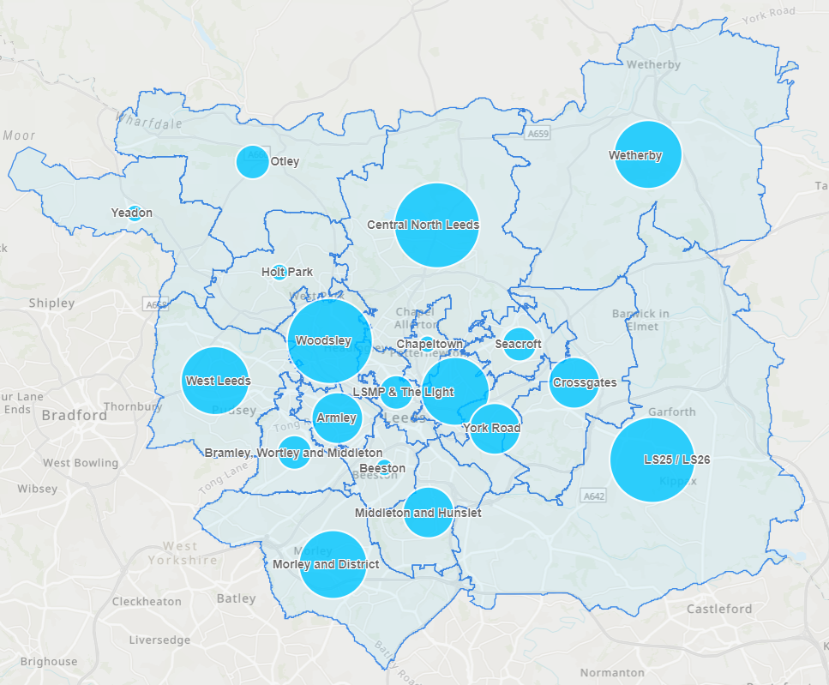

What did people tell us?

Do you have an active PPG?
From the 60 practices who responded. 49 of them (82%) indicated that they had a PPG. The remaining 11 (18%) didn’t.

Of the 49 that have a PPG:
- 39 (80%) of them met face to face.
- 10 (20%) indicated that they met virtually.

No practice indicated that they used both face-to-face and virtual meetings.

When was your last meeting?
The majority of practices that responded (34, 55%) have held a PPG meeting in 2023. The table below details the range of responses, indicating where a practice has a PPG or not and in the year they last met.

 | 2018 | 2019 | 2020 | 2021 | 2022 | 2023 | No date
Active PPG – Yes | 0 | 2 | 2 | 0 | 3 | 34 | 9
Active PPG - No | 1 | 1 | 2 | 0 | 1 | 0 | 7

Is your practice part of a PCN PPG?
A Primary Care Network (PCN) PPG is a joint PPG meeting between all practices in a PCN area. They do not replace local PPGs, as they are still a requirement and are needed to meet local need but are useful for area wide issues / initiatives:

- 10 responses (16%) said they were part of PCN PPG.
- 43 responses (69%) said they were not part of a PCN PPG.
- 9 responses (15%) said they may be part of a PCN PPG.

If you don’t have a PPG, what are you doing to reinstate it?
Of those practices without a PPG currently, some methods they identified they were using to get a practice PPG up and running again included:

- Advertising in the practice
  - Noticeboards
  - Newsletters
- Advertising online
  - Website
  - Social media
- Using the ‘PPG leaflet’ or other sign-up form.
- Seeking places to host a PPG.
- Contact patients directly
  - Phone calls
  - Email
  - Texts
  - Using AccuRx
- Advertising on printed prescriptions.
- Setting up virtual meetings.
- Invite people to a coffee morning.
- Hold meetings as part of wider Primary Care Network (PCN) PPG
- Develop an action plan.

What are your views on PPGs?
Of the responses received on this question:
- 19 of them (31%) were positive about PPGs.
- 18 of them (29%) were negative.
- 14 (23%) were a mixed response of positive and negative thoughts on PPGs.
- 4 (7%) responses were neutral.
- 7 respondents (11%) didn’t answer this question.

Positive feedback
The most mentioned positive theme was that PPGs were useful. It is noted that some of these comments did come with additional context (please see the ‘Mixed feedback’ section, below).

Practices identified that PPGs:

- Were important, good for the practice, and helped them understand patients’ point of view through ‘valuable insight’.
- Helped practices hear “what patients actually want”.
- Helped support the practice, the wider community, as well as supporting communication with patients.
- They are a good idea, great for generating new ideas, and a good way to see improvements that are being made.
- Are valuable and productive.

Quotes
“PPGs are great to get ideas and get our patient population involved”.

“[PPGs] bring valuable insight where patients feel improvements can be made. Can allow us to hear what the patients actually want and how best we can deliver”.

“[They’re] good – we get lots of support and feedback from them”.

“[They] have an important role in primary care communication to patients”.

Negative feedback
The most mentioned negative theme was around lack of interest / enthusiasm from current PPG members, as well as a general lack of interest / enthusiasm in recruiting new members to the group.

Feedback included:

- It’s difficult to get a mix of demographics in group membership. Often the membership is often White, British, over 65-year-old people, and a younger / more diverse voice is more difficult to engage (such as students and people from diverse ethnic communities).
- Finding members who want to get more involved and be ‘active’ rather than just listening to updates was difficult. Some of the feedback relates to PPG members coming to listen to updates but not being proactive and taking responsibility in helping support the practice.
- That meetings didn’t feel useful, sometimes as a result of members not understanding the role; members came to complain, which isn’t the role of the group, and that meetings can get derailed if members come with their own agenda or dominate the meeting.
- It’s a ‘contractual requirement’ that is a lot of work and can feel like a waste of time and resource, which could be better spent elsewhere.
- Some feedback spoke of feelings that PPGs ‘achieve nothing’, aren’t successful / effective, and are of limited benefit, creating a feeling of apathy towards the groups.

Quotes
“[I’m] not keen, in our area we struggle to get and retain members. During meetings, we get little useful input from members, either their feedback is glowing and is unactionable, or their feedback is regarding a particular incident that would be better handled as a complaint.”

“’[PPGs are] a contractual requirement – feel time could be better spent as patients not interested.”

“Challenging to get a wide range of ages to the group. Mostly over 65s who have retired or work part time. We tried an online PPG during the pandemic for a younger population, but very little response.”

“People use it to voice complaints, rather than be constructive.”

“A waste of precious time while NHS staff are under massive strain. Moaning session for patients.”

“I think our group is just waiting for information to be passed on from us rather than them taking the lead!”

“Waste of time if patients don’t bother turning up.”

Mixed feedback
The other main theme that came through from people related to that PPGs have potential to be a positive force in GP practices but need additional support to allow that to happen. That support included:

- Clear role and purpose.
- Good management.
- A good mix of people who understand the group’s role and remit.
- Need to be well chaired.
- Supported to be ‘self-sufficient’, that they can do things themselves and are ‘active’.
- One size model doesn’t fit all, so groups need to be dynamic in how they are delivered to ensure it works for the needs of the members, staff, and the practice.

Quotes
“I think they are effective if managed well and there is a clear understanding of their role and purpose.”

“Informative and productive, if run correctly.”

“Lovely people who like to attend and listen to updates, give their views, however, don’t want to get too involved.”

“Valuable when you have an engaged patient base, waste of time when you don’t – one size doesn’t fit all.”

“Can be helpful if they have some clear areas of work / objectives / targets.”

“A lot of work to get setup and potentially adding less value if not well-chaired or self-sufficient.”

What are some of the barriers to an effective PPG?
The key barriers to effective PPGs outlined in the responses were:

- Lack of patient engagement / interest.
- Lack of time.
- Diversity in membership.
- Difficulty in recruiting ‘active’ members.
- PPGs being used as a complaint forum.
- Members coming with personal agendas.
- Group is unclear on its role and purpose

Some other barriers identified in the responses included:

- Hosting meetings face-to-face.
- Needing to have different times / days for meetings.
- Members not understanding how GPs work.
- Getting people to attend meetings.
- Focusing on the negatives.
- Concerns that people will only come to “abuse practice staff”.
- The managing of the group.
- Communication.
- Lack of resource.
- Unsure how best to host meetings.
- People being too busy to be involved.
- Administration time.
- Lack of incentive to get involved.
- Members not taking any responsibility.
- Lack of consistency in attendance
- A patient PPG chair (to further personal agendas)

Are you aware of the PPG resources available?
The Leeds Office of the NHS West Yorkshire Integrated Care (ICB in Leeds, formerly NHS Leeds Clinical Commissioning Group), has worked with the Leeds PPG Network and practices to develop a range of tools and resources to help support PPGs and practices in developing their PPGs. These include:

- PPG Toolkit – the toolkit is a collection of resources, hints, and tips for GP practices and their PPGs. It is a freely available digital resource with a number of templates that can be tailored to each practice. The templates are available as Word documents so you can customise them to suit your practice.
- PPG Emails – to assist with communication and to respond to a direct frequently requested ask from PPGs, email addresses are available to each PPG in Leeds. This means that each group will have a dedicated email address that can be used to conduct PPG-related business.
- PPG Leaflet – a physical and digital (that can be customised and printed) leaflet to give a brief introduction PPGs and how people can get involved. These can be made available in reception.

We asked responders to tell us if they were aware of these resources:
- 35 responses (57%) said that they were aware of the resources.
- 19 responses (31%) said they were not aware of the resources.
- 7 responses (11%) were unsure.
- 1 response (2%) didn’t answer the question.

The resources are available here: https://www.healthandcareleeds.org/have-your-say/shape-the-future/ppg/resources/

How do you promote your PPG / involvement opportunities?
The top three methods of promotion by practices identified were:

- Promotion on practice website (how visible the PPG information is varies between practices) – 43 responses (69%)
- Using noticeboards in the practice – 14 responses (23%)
- Facebook – 13 responses (21%)

Other methods used included:

- Text messaging patients
- Newsletters
- Leaflets
- Using the new patient welcome letter
- Adding it onto printed prescriptions
- Minutes of meetings in the waiting areas
- Creating a PPG banner
- PPGs being involved in vaccination activities (supporting the sessions)
- QR codes
- Using AccuRx
- TV screen in the practice waiting areas
- PPG members chatting with patients in waiting areas
- Registration forms
- Direct conversation in response to complaints / feedback
- Emails
- E-consultation
- Posters in the waiting room
- Patient surveys
- Speaking to patients directly
- News articles
- Calling patients
- Setting up coffee mornings

Do you require any support?
Part of the role of the Primary Care team and Involvement team at the ICB in Leeds is to provide various levels of support and guidance with patient involvement and PPGs. We asked practices to indicate if they felt they needed some support relating to PPGs:

- 7 responses (11%) said they did.
- 27 responses (44%) said they didn’t.
- 26 responses (42%) said they may need support.
- 2 responses (3%) didn’t answer this question.

Themes
- There is a general agreement that PPGs are an important part of the practice and are useful in representing the patient voice.
- PPGs help bring new ideas and points of view to practice development.
- Lack of engagement and enthusiasm from patients is a barrier to making PPGs work.
- A lack of diversity in membership (in both age and other demographics) is a barrier to making PPGs effective and representative.
- A lack of understanding on the role of PPGs from members can lead to the group losing focus and becoming a ‘complaints forum’.
- Practices identified areas of support that would help overcome barriers to making PPGs work, which include:
  - Clear role and purpose.
  - Good management.
  - A good mix of people who understand the group’s role and remit.
  - A good Chair of the group.
  - Supported to be ‘self-sufficient’, that they can do things themselves and are ‘active’.
  - One size model doesn’t fit all, so groups need to be dynamic in how they are delivered to ensure it works for the needs of the members, staff, and the practice.
- Some practices are aware of the tools and resources available (PPG Toolkit, PPG emails), but a significant number were unsure if they knew about them.
- Practices have a number of ways to promote and advertise their PPGs, the most common methods being practice websites, in-practice noticeboards and Facebook.
- The majority of practices surveyed are not involved with a Primary Care Network PPG.

What happens next?
We will use the findings in this report to update our PPG tools and resources with relevant information. The Primary Care and involvement teams will use the insight gained to help inform how they support practices. The insight will be used alongside feedback gathered from patients and PPG members to help inform future PPG support and development.

We want to take this opportunity to thank all the practices who took the time to share their thoughts and feedback, it’s truly appreciated.

If you have any questions about this report, please contact adam.stewart1@nhs.net or call 0113 221 7723.

Appendices

Appendix A – List of practices we heard from

- Abbey Grange Medical Practice
- Aire Valley Surgery
- Aireborough Family Practice
- Alwoodley Medical Centre
- Armley Medical Practice
- Arthington Medical Centre
- Ashfield Medical Centre
- Ashton Medical Centre
- Bellbrooke Surgery
- Bramham Medical Centre
- Bramley Village
- Burley Park Medical Centre
- Burton Croft Surgery
- Church Street Surgery
- Collingham Church View Surgery
- Colton Mill Medical Centre
- Conway Medical Centre
- Crossley Street Surgery
- Dr S. Laybourn and Partners (The Medical Centre)
- The Family Doctors
- Foundry Lane Surgery
- Fountain Medical Centre
- The Garden Surgery
- Garforth Medical Centre
- Gibson Lane Practice
- Gildersome Health Centre
- High Field Sujrgery
- Hillfoot Surgery
- Kippax Hall Surgery
- Kirkstall Lane Medical Centre
- Laurel Bank Surgery
- Leeds City Medical Practice
- Leeds Student Medical Practice
- Leigh View Medical Practice
- The Light Surgery
- Lingwell Croft Surgery
- Manor Park Surgery
- Meanwood Group Practice
- Moorfield House
- Mulberry Street Practice
- North Leeds Medical Practice
- Nova Scotia Medical Centre
- Oakwood Lane Medical Practice
- Oakwood Surgery
- Oulton Medical Centre
- The Practice, Lincoln Green
- Priory View Medical Centre
- Robin Lane Health and Wellbeing Centre
- Shadwell Medical Centre
- Shaftesbury Medical Centre
- Shakespeare Medical Practice
- South Bank Surgery
- South Queen Street Medical Centre
- Spa Surgery
- The Street Lane Practice
- Thornton Medical Centre
- Westgate Surgery
- Whitehall Surgery
- Windmill Health Centre
- Woodhouse Medical Practice

Appendix B – Response rate by Primary Care Network (PCN)
You can view the different PCN areas and the practices that sit within them on the Leeds GP Confederation website: https://www.leedsgpconfederation.org.uk/about-us/our-practices/

Primary Care Network | Number of practices in PCN | Number of practices who responded to the survey | % response rate
Armley | 3 | 3 | 100%
Beeston | 6 | 1 | 17%
Bramley, Wortley and Middleton | 6 | 2 | 33%
Burmantofts, Harehills and Richmond Hill | 13 | 4 | 31%
Central North | 8 | 5 | 63%
Chapeltown | 6 | 1 | 17%
Cross Gates | 6 | 3 | 50%
Holt Park | 2 | 1 | 50%
LS25 / 26 | 12 | 5 | 42%
Leeds Student Medical Practice and The Light | 2 | 2 | 100%
Middleton and Hunslet | 4 | 4 | 100%
Otley | 4 | 2 | 50%
Seacroft | 4 | 2 | 50%
West Leeds | 8 | 4 | 50%
Wetherby | 7 | 4 | 57%
Woodsley | 13 | 5 | 39%
Yeadon | 5 | 1 | 20%
York Road | 5 | 3 | 60%

