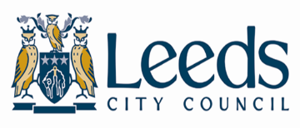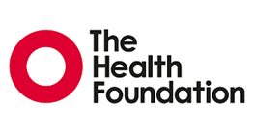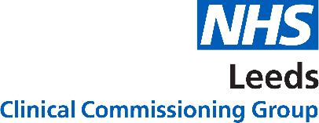

20 October 2021

**Media Release**

**The NHS in Leeds and Leeds City Council work in partnership on exciting national project to use data to improve health and social care**

The [Networked Data Lab](https://www.health.org.uk/funding-and-partnerships/the-networked-data-lab) is a new collaborative of advanced analytical teams across the UK. They are working together on shared challenges and promoting the use of analytics to improve health and social care. Thanks to the Leeds Data Model, NHS Leeds CCG and Leeds City Council are one of five partners across the country who have successfully bid for £400,000 to take part in the initiative.

The project will look at **how partners can work together to use data to improve health and care in the UK**, including addressing COVID-19 and widening health and care inequalities. It will do this by identifying and analysing three data sets over three years. The first data set focused on people who were advised to shield at various points during the pandemic This group of patients are the ones deemed the most at risk of becoming seriously ill from COVID.

**Councillor Fiona Venner, Executive Member for Adult and Children’s Social Care and Health Partnerships, Leeds City Council**, commented: “During the course of the pandemic, over 70,000 people in Leeds were advised to shield at home; this meant they were advised not to leave their homes and to minimise all face-to-face contact with others – even with people they lived with.

“Although the risk to the CEV people is significantly lower, and the advice to shield is no longer in place, we know that people in this group still need support. Therefore, local practical and emotional support continues to be available for people who need to reduce their risk, and we continue to ensure people are well informed about the support that is available.

“However, we know there are much wider health consequences of the pandemic, such as poorer mental health, and that people from the CEV group have been disproportionately affected. The Network Data Lab project has given us a deeper understanding of those issues, which means we can continue to adapt the support available for people in the clinically extremely vulnerable group.”

The Leeds Data model imports health and social care data from organisations including hospitals, GP practices, urgent care including 111 and ambulance, community and mental health, maternity, adult social care and population data. This information is depersonalised which means identifiable items such as name, date of birth, address and NHS number are removed and replaced by a unique number.

Linked data sets will allow us to combine similar information from different organisations. Working in this way enables us to better understand the health of our population and how they use our services. We can use this insight to design population-focussed services and improve health outcomes in Leeds.

An important part of the NDL project is involving patients and the public in the project to ensure that data is used in a legitimate and transparent way and recognises patients, carers and the public as stakeholders with rights and responsibilities for publicly funded services. This ensures we don’t make assumptions about people’s experience of health and social care and that we focus on reducing health inequalities.

**Patricia McKinney, CCG Volunteer** on the project said, “This is such an exciting project to be involved with, demonstrating how health and care data can reveal what is going on in the health and care system”.

**Frank Wood Chief Analytical Officer for Leeds City Council and CCG** said, “We are in the fortunate position in Leeds to have access to data linked together in this way. This is a great opportunity to work with NDL partners across the UK to better understand and analyse health and care data, enabling us to share learning and approaches”.

Ends

Notes to editors

Media contact

Helen Butters

hbutters@nhs.net

07737704992

About the Networked Data Lab

The Networked Data Lab is a collaborative network of advanced analytical teams across the UK. Led by the Health Foundation, we work together on shared challenges and promoting the use of analytics in improving health and social care. Using linked data, we aim to understand and solve the toughest health and care issues facing the UK today.

• The Networked Data Lab is comprised of the following partners:

• The Aberdeen Centre for Health Data Science (ACHDS) which includes NHS Grampian and the University of Aberdeen

• Public Health Wales, NHS Wales Informatics Service (NWIS), Swansea University (SAIL Databank) and Social Care Wales (SCW)

• Imperial College Health Partners (ICHP), Institute of Global Health Innovation (IGHI), Imperial College London (ICL), and North West London CCGs

• Liverpool CCG and Healthy Wirral Partnership

• Leeds CCG and Leeds City Council

About the Health Foundation

The Health Foundation is an independent charity committed to bringing about better health and health care for people in the UK.

www.health.org.uk