# Proposal to Merge Rutland Lodge Medical Practice, Oakwood Surgery and Shadwell Medical Centre

**Engagement Report**

**15 August 2023**

Engagement period: 01.06.2023 to 15.07.2023

Authors: Lynne Doyle, Paula Dearing, Donna Marks

## Executive Summary

Following a Care Quality Commission (CQC) inspection in June 2021, Shadwell Medical Centre was given an ‘inadequate’ rating. The practice contract was taken over by the Central North Primary Care Network (PCN) – a group of local GP practices that work together to improve primary care services. The latest CQC inspection in January 2023 reported significant improvements and the practice is now rated as ‘good’.

The Leeds Office of the NHS West Yorkshire Integrated Care Board (the ICB in Leeds) are now looking at a long-term solution for the management of Shadwell Medical Centre. In Spring 2023, Oakwood Surgery and Rutland Lodge Medical Practice approached the ICB about merging with Shadwell Medical Centre. They want to work together so that they can increase the number and type of service available to local people.

Oakwood Surgery, Rutland Lodge Medical Practice, and Shadwell Medical Centre are all based in northeast Leeds, and all have a CQC rating of ‘good’. Together they provide primary care services to around 19,500 people.

The ICB in Leeds asked us to share our proposal with our registered patients to understand the views of the local population. This involvement ran from 1 June to 15 July 2023 and:

* Informed our patients about the proposal.
* Gave our patients an opportunity to share their views on the proposed change.

We wrote to all registered households to tell them about the change and ask for their views. We also worked together to carry out a number of activities to support the involvement including:

* An online survey, which was also available as a paper version.
* Three drop-in events where people could find out more about the change and ask questions.
* Organised meetings with our Patient Participation Groups (PPG).

177 people were engaged with the involvement activities. The involvement identified several key themes, including:

* The importance of getting an appointment with the requested GP at the chosen surgery; continuity of care
* The impact on getting through on the phone lines at 8am.
* The number of patients across the three surgeries reducing the personal feel of the smaller surgeries.
* Admin and support staff not being supported and losing their motivation and empathy for patients.
* Access for disabled patients at the surgery closest to them.
* Having to travel further to see a healthcare professional.
* Increase in other services and more choice of who to see.
* Mitigates risk of being unable to recruit to small organisations.
* Good idea to share resources and expertise.

This report gives a background to the change and outlines how we involved people. This report details what people told us during the involvement and outlines how we have responded to their feedback. The report will be shared with all those involved in the involvement and will be made available on our practice websites. It will also support the general development of local health and care services in Leeds.

## Background

## How did we identify and involve patients and wider stakeholders?

We have a legal and a moral responsibility to involve local people when we propose to make changes to our services. Our plans needed to consider who lives in the areas we service, which other organisations and people we needed to involve and how to be accessible to all communities.

We identified a number of key stakeholders that we needed to engage with through this involvement including local councillors and Healthwatch Leeds.

* Prior to the engagement commencing we met with Patient Participation Groups to discuss ways in which patients’ voices could be heard.
* We developed a range of ways to involve registered patients in the change.
* We held three meetings (one at each surgery) with GP partners and practice managers in attendance where patients were invited to give feedback and ask questions.
* We liaised with local GP practices within the area to ensure they were aware of the proposed changes.

### Letters to registered households

The surgeries sent an initial letter to all households registered on 5 June 2023 This letter explained the changes that were proposed and included a link to the survey document to allow patients to submit questions. It also contained details of the three public meetings which the patients were welcome to attend in person to ask questions. A direct telephone line was provided to answer patients’ questions.

### Patient survey

Our letter to patients provided a link to an online survey where patients could share their views about the change. The survey was also available in paper format.87 people shared their views using the survey.

### Public events

We arranged three public events that patients could attend if they wished to do so at each of the three practices; two were held during the daytime and one in the evening. The meetings were attended by the practice managers from the surgeries and representatives from the ICB in Leeds, and GP partners from Rutland and Oakwood.

A total of approximately 90 patients attended the meetings.

## Who took part in our involvement?

### Information about people who were involved in this work

We collected equality monitoring information for some of our involvement activities. This allows us to understand who is sharing their views and, more importantly, where the gaps in feedback are. For this involvement we only collected equality monitoring information through our survey.

### Response by practice

The survey was returned by:

* 52 patients from Oakwood Surgery
* 2 friends, relative or carer of a patient at Oakwood Surgery
* 20 patients from Rutland Lodge
* 1 patient from Carlton Surgery
* 1 friend, relative or carer of a patient at Carlton Surgery
* 14 patients from Shadwell Medical Centre
* 2 friend, relative or carer of a patient from Shadwell Medical Centre.

### Response by postcode

Not all respondents completed the equality monitoring section, but of the 85 that did:

* 2 told us they lived in LS6.
* 11 in LS7
* 50 in LS8
* 3 in LS14
* 19 in LS17.

### Response by age

There was a broad spread of age ranges from the respondents who told us their age:

* 2 respondents were aged between 26 and 35.
* 8 respondents were aged between 36 and 45.
* 11 respondents were aged between 46 and 55.
* 27 respondents were aged between 56 and 65.
* 25 respondents were aged between 66 and 75.
* 10 respondents were aged between 76 and 85.
* 3 respondents were aged 86 or over.
* 1 respondent preferred not to say.

### Response by Gender

* 32 respondents described themselves as male.
* 51 respondents described themselves as female.
* 2 respondents described themselves in another way.

### Response by ethnicity

Not all respondents completed this section, but of those that did:

* 70 respondents were White British
* 1 respondent was Arab.
* 2 respondents were Asian or Asian British Indian
* 1 respondent was Asian or Asian British Pakistani
* 1 respondent was Black, African, Caribbean, or Black British African
* 1 respondent was Black, African, Caribbean or Black British Caribbean
* 1 respondent was White Irish
* 4 respondents preferred not to say.
* 4 respondents were other – Latin-American, Vietnamese, Arab British and mixed.

**Response by religion and belief**

Not all respondents completed this section, but of those that did:

* 39 respondents chose Christianity.
* 30 respondents chose no religion.
* 3 respondents chose Jewish.
* 3 respondents chose Muslim.
* 2 respondents chose Hindu.
* 6 respondents preferred not to say.
* 1 respondent chose other.

**Response by disability**

* 13 respondents told us they believed they had a disability.
* 73 respondents told us they did not.

**Type of disability**

* 7 respondents told us they had a physical or mobility impairment.
* 9 respondents told us they had a hearing impairment.
* 3 respondents told us they had a sight impairment.
* 3 respondents told us they had a mental health condition.
* 17 respondents told us they had a Long-Term Condition
* 12 respondents told us they had other disabilities.
* 10 respondents preferred not to say.

## What people told us?

### What matters to people when they use their GP Practice?

We asked people to tell us about their thoughts on the merger and how this would impact on them. We also asked people to tell us what was most important to them when they use our primary care services. We will use this feedback to shape our decisions about other health services in the future.

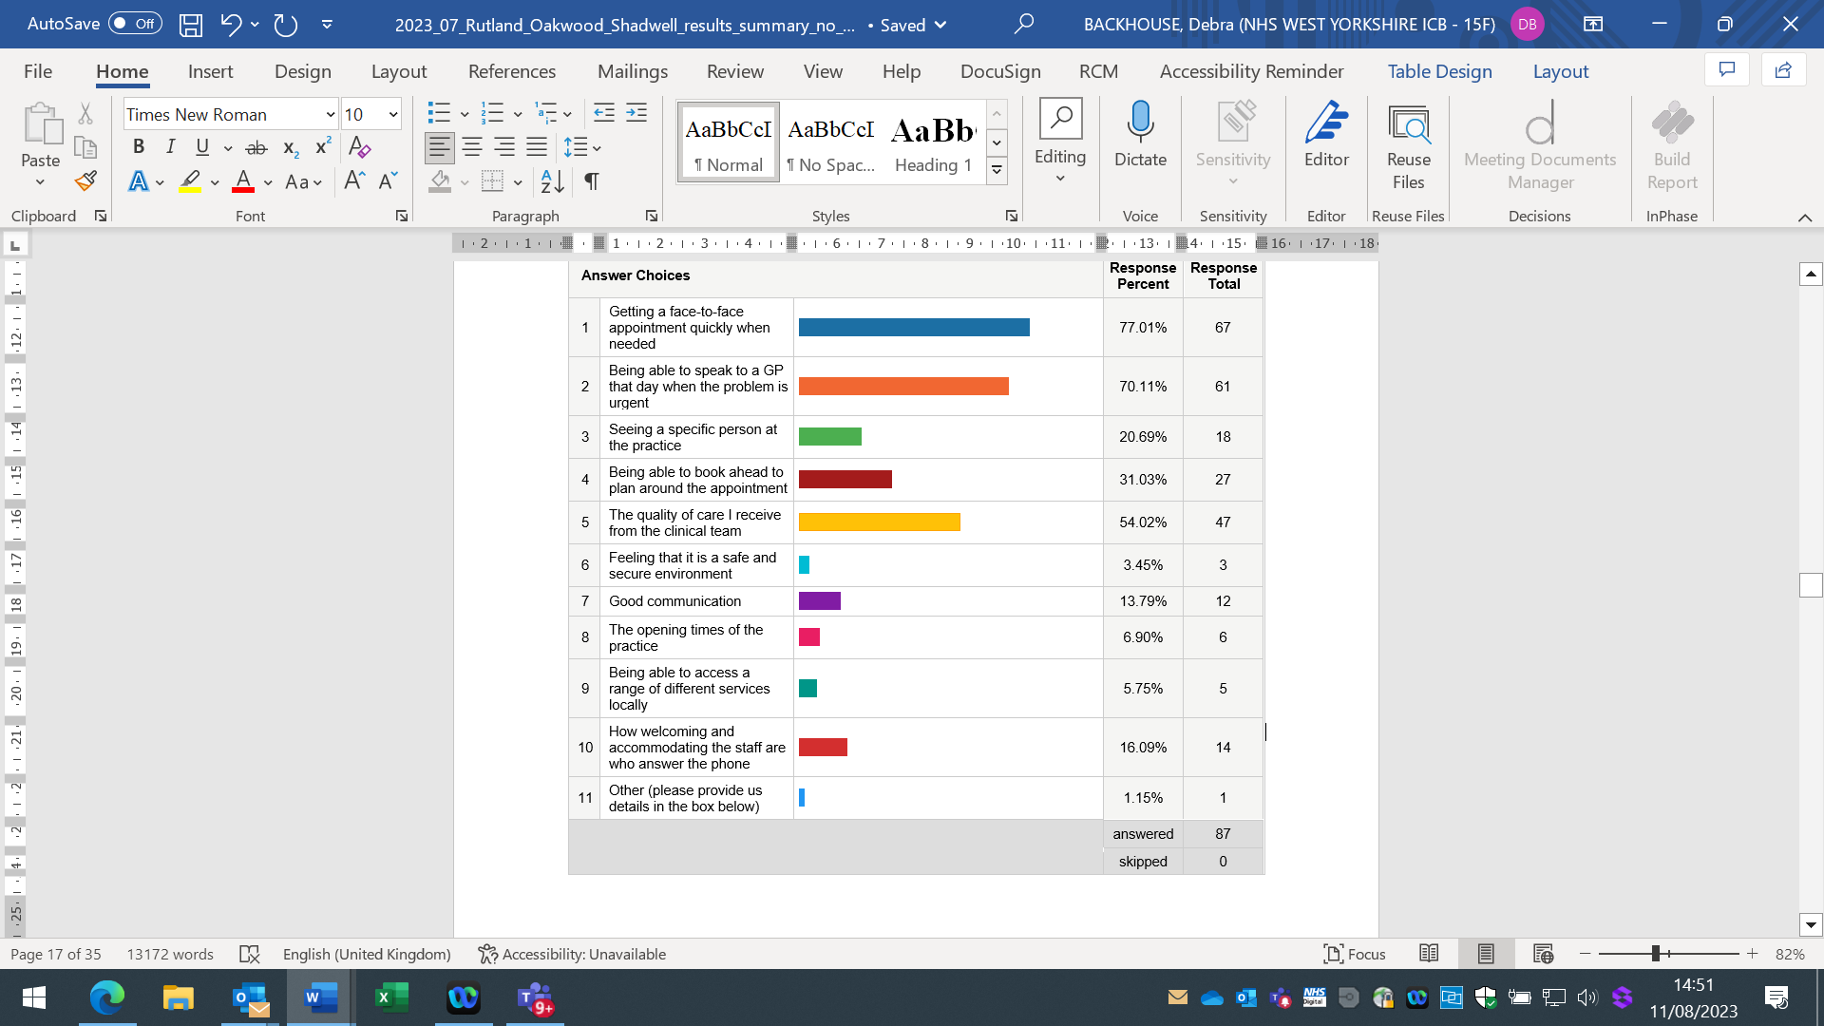

* 67 people (77%) said getting a face-to-face appointment quickly when needed was important.
* 61 people (70%) said being to speak to a GP that day when the problem is urgent was important.
* 18 people (21%) said that seeing a specific person at the practice matters to them.
* 27 people (31%) said being able to book ahead to plan around the appointment was important.
* 47 people (54%) said that the quality of care they receive from the clinical team mattered to them.
* 3 people (3%) said that feeling that the practice is a safe and secure environment mattered to them.
* 12 people (14%) said that good communication mattered to them.
* 6 people (7%) said that the opening times of the practice was important to them.
* 5 people (6%) said that being able to access a range of different services locally mattered to them.
* 14 people (16%) said that how welcoming and accommodating the staff are who answer the phone mattered to them.
* 1 person (1%) said an other thing mattered to them.

### Examples of comments and concerns

**Some people told us that they were concerned the merger would make it more difficult to get an appointment with their GP.**

“I already struggle to get an appointment with my GP – merging with other practices will make it worse.”

**Many people told us that they valued the service they received at their practice and that they wanted this to continue if the practices merge.**

“I’m really happy with the service I get from Rutland Lodge. The staff are kind, and I can always see a clinician when I need to. I hope that continues if the practice decides to merge.”

**Some people told us that seeing the GP of their choice was very important to them.**

“Will this change make it more difficult to see a specific doctor? My doctor knows me really well and I prefer to see her when I make an appointment.”

**People who are deaf or hard of hearing told us that they received an excellent service from Shadwell Medical Centre, and it was important for this to be available if they visited other sites after the merger.**

“As a deaf person it can be difficult accessing some services. I’m worried that the services at the other practices won’t be as good as Shadwell.”

We invited people taking part in the survey to stay in touch if they were interested in joining their local PPG, finding out more about opportunities to shape health and care decision making or receive the report from this involvement work.

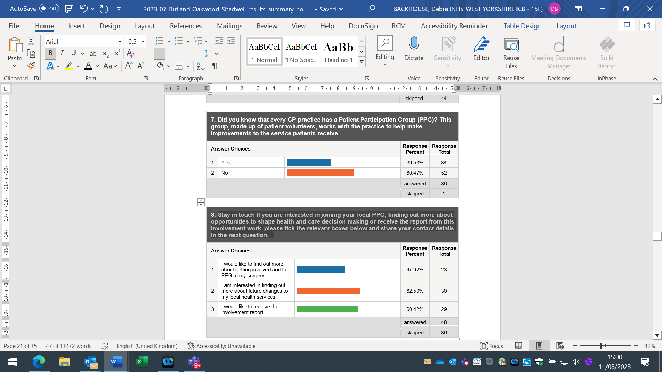

* 23 people (48%) said they would like to find out more about getting involved in the PPG.
* 30 people (63%) said they were interested in finding out more about future changes to local health services.
* 29 people (60%) would like to receive the involvement report.

We asked if patients used online services to request repeat medication or make an appointment. A total of 85 people responded to this question, of which 71 replied yes. Reasons for not using included:

* Impersonal
* Not aware/never asked to register
* Not computer literate
* Prefer to speak to a receptionist

## Key themes and actions

We identified a number of key themes during the involvement. Here we outline those themes and what we are doing or planning to do to address them.

| **Theme** | **Action** |
| --- | --- |
| Some people told us that they were concerned the merger would make it more difficult to get an appointment with their GP. | Patients will still have a choice of who to see at their preferred site.  Not all appointments need to be with a GP. Some research undertaken by NHS England (NHSE) has indicated that 24% of the patients seen by a GP could have been treated by another healthcare professional.  We work with other practices in the area as part of the Central North Primary Care Network employing a variety of other clinical staff including pharmacists, paramedics, OTs and Health and Wellbeing Coaches |
| Many people told us that they valued the service they received at their practice and that they wanted this to continue if the practices merge. | We will ensure patients can still be seen by their chosen health professional at their preferred site.  Services will not be diminished, and other services will become available due to the merger |
| Some people told us that seeing the GP of their choice was very important to them. | As a rule, GPs prefer to follow up their consultations with patients by seeing them again. This is best for the GP and the patient. On occasions where the patient needs to be seen urgently this is not always possible. We have a mix of full and part-time GPs. If a patient needs a clinical review and their usual GP does not have any available appointments, this may need to be undertaken by another GP |
| People who are deaf or hard of hearing told us that they received an excellent service from Shadwell Medical Centre, and it was important for this to be available if they visited other sites after the merger. | This is available at all of the practices.  All sites comply with the Equality Act (2010) and Accessible Information Standards (2016).  Patients should not see any deterioration in standards. |
| Many people told us they have concerns about travelling to an appointment at another practice due to transport links. | Patients will not be asked to travel to other practices unless they choose to do so.    However, if they choose to travel then transport links are available with some direct bus routes between the surgeries.  We have found that patients are willing to travel to extended access appointments at Rutland Lodge hub in the evenings and weekends. |
| People told us they were concerned about moving to a single phone number for appointments and the easy of getting through to the practice. | We will ensure sufficient staff are available to answer the phones and patients will be asked where they want to be seen.  We will also encourage the use on online access to ensure patients are seen in a timely manner. |

## What happens next?

Our application to merge our practices needs to be approved by the Leeds Office of the NHS West Yorkshire Integrated Care Board (the ICB in Leeds). This is the organisation that plans and pays for (commissions) NHS services in Leeds.

This report is one of many documents that we will share with the ICB Primary Care Board in date. They will consider our application and make sure we can continue to provide high quality, safe and sustainable services for our patients. At the meeting they will make a decision about whether we can progress with the merger.

Once a decision has been made, we will write to all registered households to inform all our patients.

# Contact information

If you have any queries regarding this involvement, please contact [rutland.reception@nhs.net](mailto:rutland.reception@nhs.net) or ring 07751 544668.

**Alternative formats:**

If you need this information in another language or format please contact [rutland.reception@nhs.net](mailto:rutland.reception@nhs.net) or ring 07751 544668.

‘Jeśli w celu zrozumienia tych infomacji potrzebuje Pan(i) pomocy w innym języku lub innej formie, prosimy o kontakt pod numerem tel: 07751 544668 lub poprzez email na adres: [rutland.reception@nhs.net](mailto:rutland.reception@nhs.net)

اگرآپ کو ان معلومات کو سمجھنے کے لیئے یہ کسی اور زبان یا صورت میں درکار ہوں تو برائے مہربانی سے اس نمبر پر فون کرکے رابطہ کریں: 07751 544668 یا اس پتہ پر ای میل لکھیں: [rutland.reception@nhs.net](mailto:rutland.reception@nhs.net)

